EQUATOR RESOLUTION
Institutional Mediation, Conciliation & POSH Support

Forum Interface Map (Workplace)
Where each workplace dispute belongs, and how Equator fits alongside

Workplace & HR Dispute Resolution vertical
July 2026 · Draft for legal sign-off · www.equatorresolution.com

The map
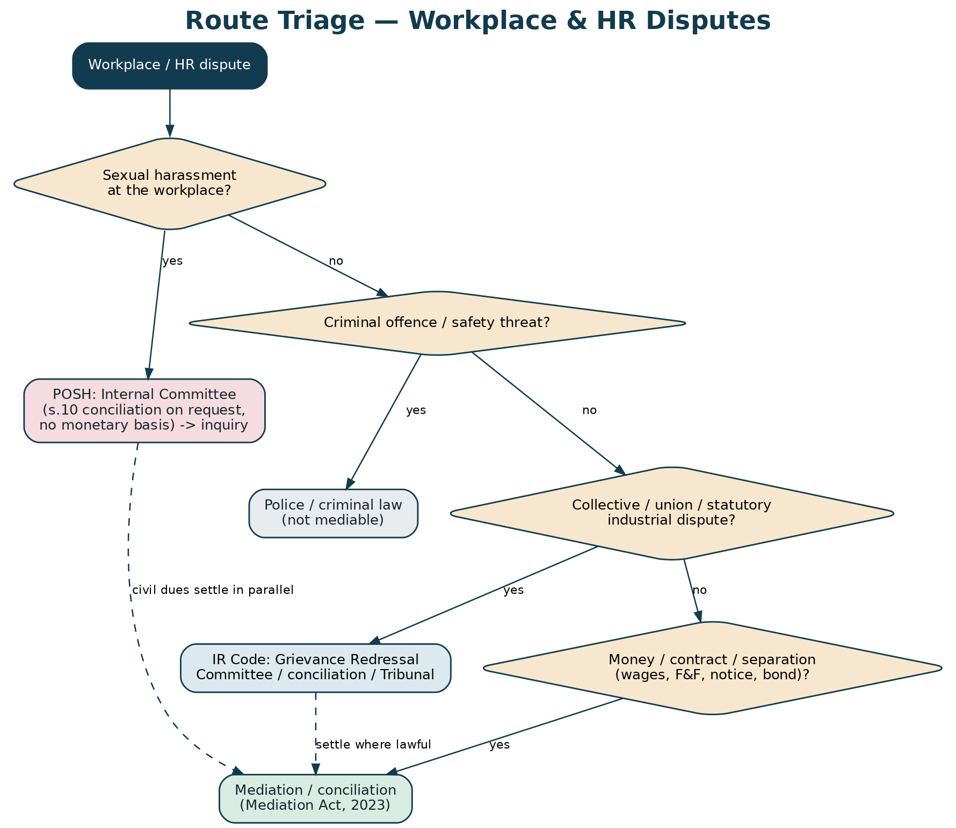
Figure — route triage across POSH, statutory and mediable matters.
Forum | When it applies | Equator's interface
Internal Committee (POSH) | Sexual harassment at the workplace | Support only: external member, sealed case management, lawful s.10 conciliation, training. Never replaces the IC.
Local Committee | Complaint against the employer, or establishment with fewer than 10 workers | Signpost; support the complainant to reach it
Grievance Redressal Committee (IR Code) | Individual grievance in an establishment of notified size | Mediate where unresolved and both sides agree
Conciliation officer / Industrial Tribunal | Collective or statutory industrial dispute | Signpost; mediate a settlement around it only where lawful
Labour authorities / inspector | Wage, PF, ESI and compliance enforcement | Signpost; a settlement does not displace statutory enforcement
Civil court | Contractual claims outside the statutory scheme | Mediate; settlement enforceable as a decree (s.27)
Police | Criminal conduct or a threat to safety | Signpost immediately; never mediate the criminal aspect
Equator mediation | Wages, F&F, separation, notice, benefits, grievance | Primary route; escrow-secured; enforceable settlement

One front door
A party does not need to know which forum fits. Triage routes the matter — and where the law reserves something to a statutory body, Equator signposts it rather than absorbing it.

